Name Grit Munk
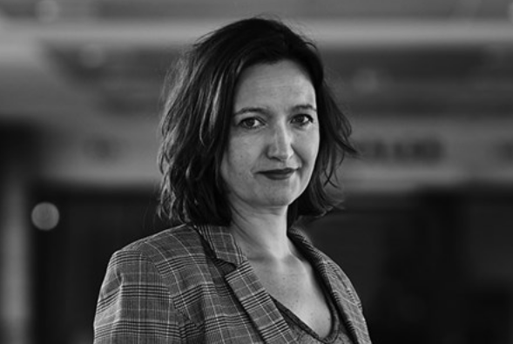

Adress IDA
Kalvebod Brygge 31-33
1780 Kbh V
Contact +45 30596596
e-mail gmu@ida.dk

Education:

1998 Cand.scient.pol./master political science,
University of Copenhagen
2019 Diploma of Leadership, Denmarks Technical University

Job:
Since 2011: Senior advisor at Danish Society of Engineers, IDA, with responsibility for IDAs policy and PR on it, cybersecurity and dataethics.
Speaker, debater and spokesperson for IDA.

Relevant faglig erfaring:
Member of ”Cybersikkerhedspagten” under the Danish Ministry of Digitisation and Equality
Member of DS/S 855 on AI
Member of ISO/IEC/JTC 1/SC 42 Artificial Intelligence
Member of CEN-CENELEC AI Focusgroup
Member of Forbrugerrådet, Tænks ”Ekspertgroup on AI and fraud”

