LeadENG project 1: Small Electric Car.

Background
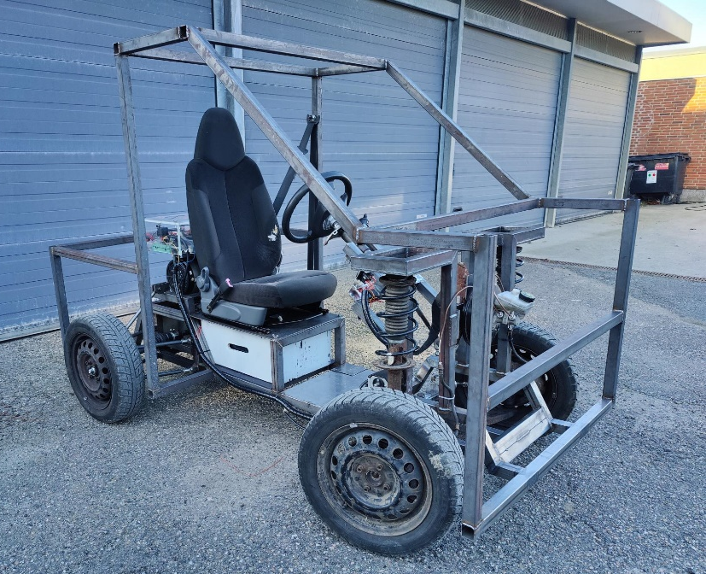
One important challenges of the 21st century is the transition from fossil fuel based transportation to more eco-friendly transportation solutions. In regards to personal cars, there is already process of changing petrol- and diesel cars to electric cars. This process is already being supported by the society and end users through more charging stations being installed and the sales on electric cars increases gradually year by year. However, there is still remain a long way ahead before Danish climate targets are within reach (i.e. 2050 climate coals for personal cars).
This LeadEng project relates to the version-2 design of a small and single seated electrical car for short and intermediate distance personal transportation. The intentions with a small electrical car is to have an energy efficient transportation/car. Secondly it is single seated since the driver her/himself is the only person in the car.
Version-1 of the car was developed by students on the 2nd semester 2021 and this project will take off from the developed prototype. Version-1 will be used for measuring structural loadings, battery/motor performance and energy consumptions under typical driving scenarios and thereby form a baseline for Version-2.
Some proposed requirements for Version-2 are listed in the table below.
The final product requirements shall be defined during the project start up.
 | Road Ready Car | Prototype Car (Version-2) | Comments
Total weight  (incl. driver and payload) | 300-500kg | 300-500kg | Version-1 approx. weight 700kg
Top speed | 80km/t | 30km/t | Speed limit on prototype version is set due to safety concern.
Driving range | 100km | 10km | 10km is set to lower cost on battery pack.
Payload | 50kg | 50kg | To be placed somewhere on the vehicle.
Estimated production volume | 100 cars/year | 1 prototype
Estimated sales price | 50 – 60.000 | - | It is assumed that cost price should be around 40.000kr.

Proposed semester projects within this LeadEng project are outlined below.

Project Description for {4 or6}^{th} Semester BSc Mechanical Engineering (MP4 or MP6):
A semester projects on redesign a modular chassis to the electric car is proposed. The chassis should be able to interface with front- and rear-suspension modules developed in the parallel MP2 semester projects. The chassis design is intended to be a frame like structure that can be made from simple welded profiles. The chassis should be designed with the objective to minimize its weight and furthermore to withstand the loadings (dynamic as well as fatigue) from typical- and extreme driving conditions.
Some proposed tasks for this project could be;

- Conduct measurement on current prototype car to identify “real” loading scenarios. (interface with MP2 and ET2)
- Design a chassis frame module based on the recorded loadings. (interface with MP2)
(optimization schemes in MatLab could be applied in the design process)
- Additional task: design an enclosed gearbox for the car (interface with ET2)
- Collaborate with the MP-workshop to manufacture the chassis frame. (interface with MP2)

Proposed project description for 2nd Semester BSc Energy (Energy2):
The project (s) will focus on the energy system – the battery and motor:
Models for calculating the required driving force/power and battery discharge capacity
Models for the battery (energy) capacity for obtaining the required driving range and typical driving behaviour for the car
Battery model for charging/discharging, maybe also some lifetime aspects of how many charging and discharging cycles can be expected from the chosen battery pack.
Experimental validation of the models, maybe initially arranged as isolated parts and then finally combined in a complete LeadENG vehicle.

Project Description for 2nd Semester BSc Mechanical Engineering (MP2):
Two semester projects are proposed. Both project takes off in the current electric car prototype made by former students. The proposed projects have their focus on optimizing the current front and rear suspension with respect to weight and driving comfort/performance and further contribute to a modular design of the car. A lighter design favor a better overall energy performance. The current front and rear suspension is rather stiff and can therefore make the driving discomfort and further adding additional (dynamic) loading to the chassis. The two projects relates to each “end” of the car.
- Design a front suspension module which include steering mechanism: (interface with MP4/MP6)
- Design a rear suspension module: (interface with MP4/MP6 and ET2)
(comment: as to day the prototype car do not have mechanical breaks on the rear wheel set. Therefore an additional task would be to include this in the design of the rear suspension module)
It is suggested that driving tests in the current car is done to measure e.g. accelerations, speed etc. when driving across/trough some defined obstacles.
These data can then be used to develop models for the suspension systems and further lead to lighter designs and potentially improved driving comfort.

