**Assigning PLSIGN and FLSIGN for H2020 projects**

To be able to add PLSIGNs and FLSIGNs, you must be added as participant contact of the project. You can check this with the coordinator, who can assign this role to you.

1. Login to the Participant portal using your ECAS login and select “My Project(s)” under the menu in the upper left corner.
2. Click on the yellow icon, named “project Consortium”

This page will then appear:

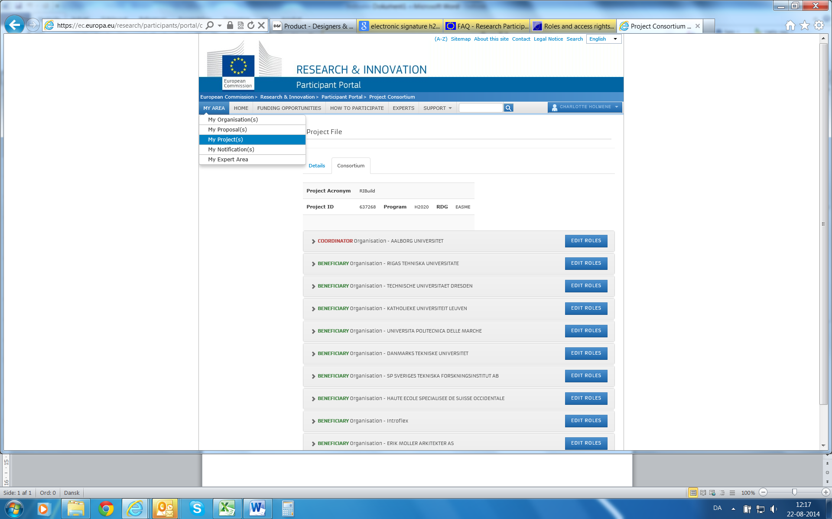

1. Select “Edit Roles” next to your organization name.
2. You can now add more roles by clicking on the blue “Add roles” botton at the end of the page. This page will now appear:

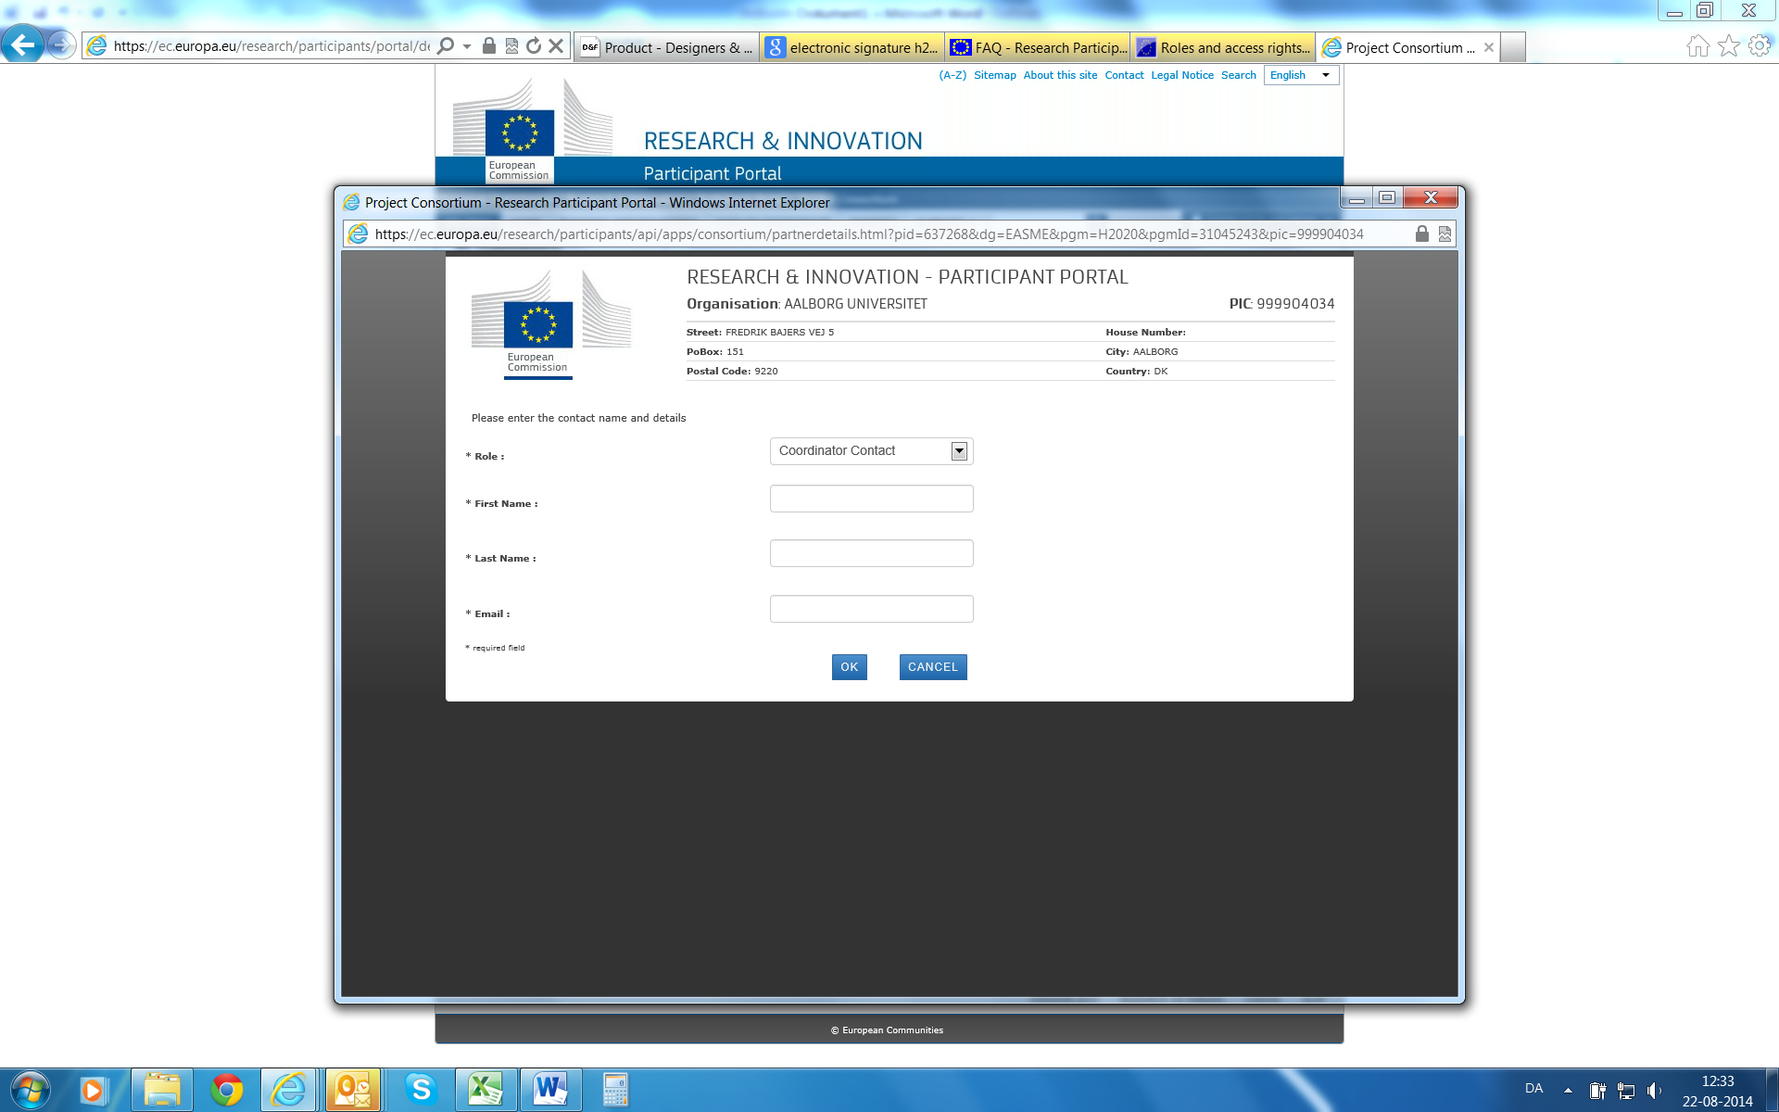

1. In the drop-down menu (see red mark) you can now select the PLSIGN (Proposed Legal Autorised Signatory) and the PFSIGN (Project Financial Signatory). When selecting one of these, a list of your organisation’s assigned LSIGNs and FSIGNs will appear, and you can now select the persons assigned to this project. When the correct person has been chosen, press “OK”.
2. You can select more than one PLSIGN and PFSIGN for the project, but you need to add each person individually.
3. The system needs some time to process the information, so you will not be able to see the changes in the system right away.