Design of electrical steering wheel system for tractor auto-guidance (LeadENG project)

Background
There is a great motivation to introduce electrical steering systems to tractors in agriculture. Equipped with auto-piloting and real-time position feedback using GPS, the tractor can be remotely controlled to perform various functions on pre-planned tracks, achieving:
- reduced skips and overlaps
- lower operator fatigue
- ability to work in poor visibility conditions
- ease of use
This LeadENG project aims to develop a demonstration and test system for such an electrical steering system. An example of such a system and its application can be found here:
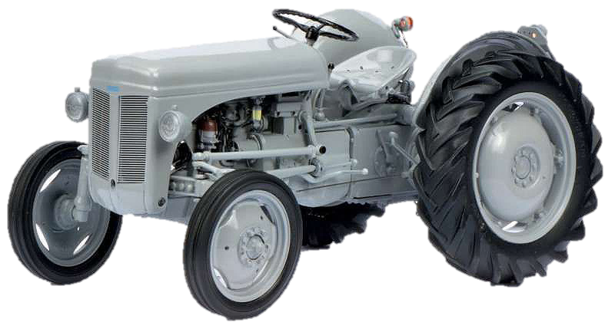
https://www.fjdynamics.com/en/product/autosteeringkit.html?utm_source=google&utm_campaign=ATK-UK-product&utm_medium=cpc&gclid=CjwKCAiA24SPBhB0EiwAjBgkhgdreMjB2U6SauDsQGm1DrMfDCU_QE3KC1zU7mZxXQ0PXvOmqVX_kxoCZoMQAvD_BwE

Objectives
The main objective of this project is to design, construct and test an electrical steering system suitable for tractor auto-guidance. It is expected that the proposed system is compact and can be installed on the existing tractors easily without too many modifications.

Contents
- Collaborate with the student group from the other department, find out the requirements for a typical steering wheel used in a tractor, i.e., required steering torque, rotational speed, load torque reflecting different road conditions.
- The initial electrical steering system will be using an existing electrical motor with (or without) a gear.
- Investigate the possibility to integrate the electrical motor and the steering wheel.
- Develop a control scheme suitable to the electrical steering wheel system.
- Build the test setup and demonstrate its electrical steering function.

Resources
- Electrical motor and inverter / controller.

Contact person:
Kaiyuan Lu (Pon111-1.119) E-mail: klu@energy.aau.dk
Dong Wang (Pon111-1.120) E-mail: dwa@energy.aau.dk

